Topic : BIG DATA

Name: Mustafa Basher El-nour Abd-elsalam

Sitting Number : 942

Section : 42

Group:7

Big data:  is a field that treats ways to analyze, systematically extract information from, or otherwise deal with [data sets](https://en.wikipedia.org/wiki/Data_set) that are too large or complex to be dealt with by traditional [data-processing](https://en.wikipedia.org/wiki/Data_processing) [application software](https://en.wikipedia.org/wiki/Application_software). Data with many fields (columns) offer greater [statistical power](https://en.wikipedia.org/wiki/Statistical_power), while data with higher complexity (more attributes or columns) may lead to a higher [false discovery rate](https://en.wikipedia.org/wiki/False_discovery_rate).[[2]](https://en.wikipedia.org/wiki/Big_data#cite_note-2) Big data analysis challenges include [capturing data](https://en.wikipedia.org/wiki/Automatic_identification_and_data_capture), [data storage](https://en.wikipedia.org/wiki/Computer_data_storage), [data analysis](https://en.wikipedia.org/wiki/Data_analysis), search, [sharing](https://en.wikipedia.org/wiki/Data_sharing), [transfer](https://en.wikipedia.org/wiki/Data_transmission), [visualization](https://en.wikipedia.org/wiki/Data_visualization), [querying](https://en.wikipedia.org/wiki/Query_language), updating, [information privacy](https://en.wikipedia.org/wiki/Information_privacy), and data source. Big data was originally associated with three key concepts: *volume*, *variety*, and *velocity*.[[3]](https://en.wikipedia.org/wiki/Big_data#cite_note-:0-3) The analysis of big data presents challenges in sampling, and thus previously allowing for only observations and sampling. Therefore, big data often includes data with sizes that exceed the capacity of traditional software to process within an acceptable time and *value.*

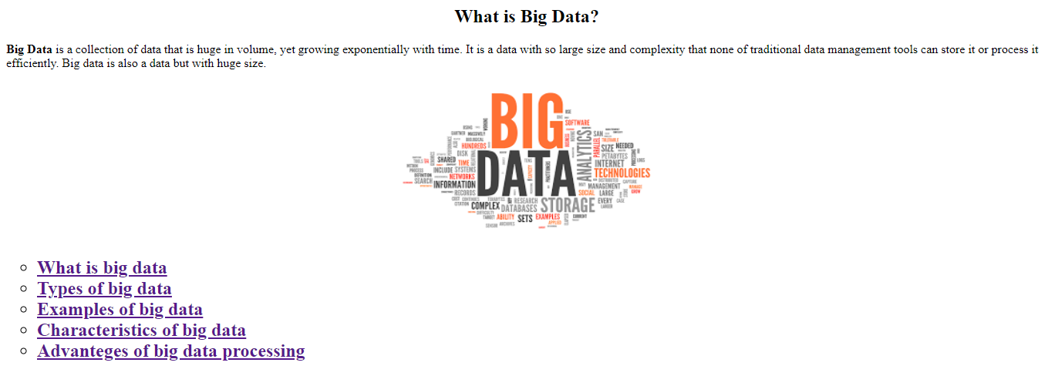source code: 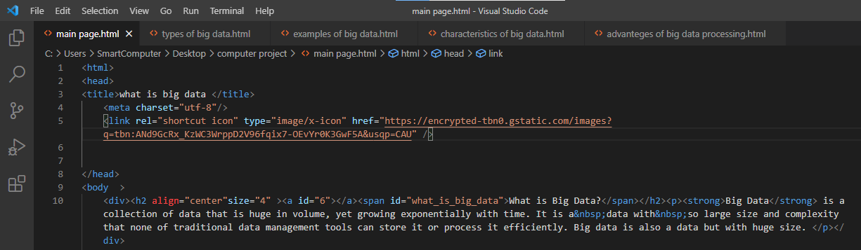

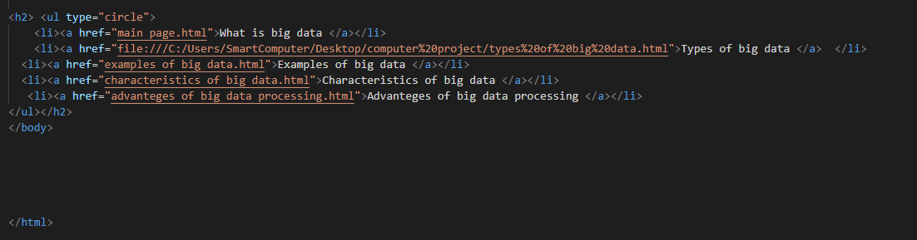

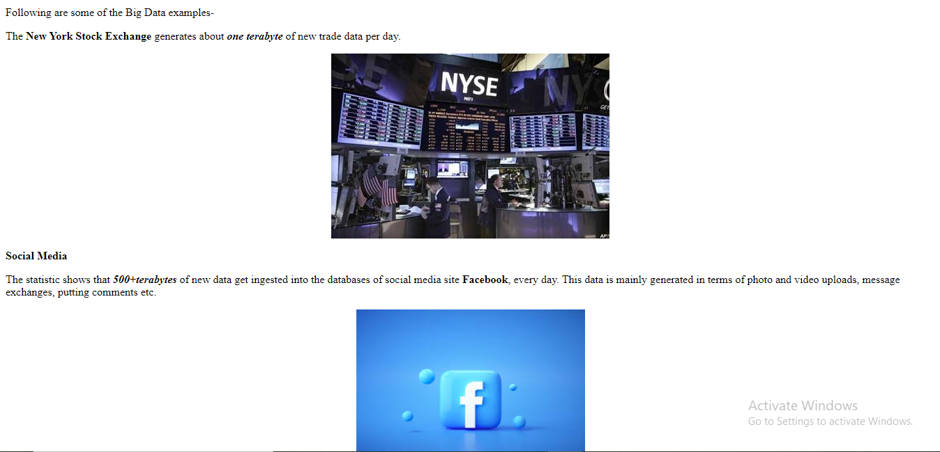

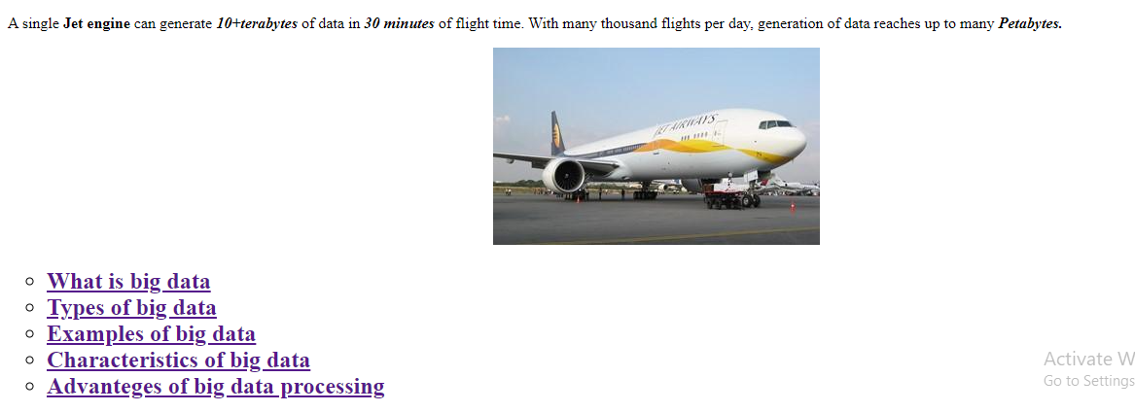

Source code: 